Plan:
- Find new journal articles relating to my topic
- Collecting related posts or hashtags from Twitter & Instagram
- Find blogs relating to my topic
- Have a more in depth conversation with my interviewee from the interview segment
Data collection:
I collected blog posts, tweets, and instagram posts that related to long distance friendships. There were discussions and opinions on the effects of the relationships. There are pros and cons and ways to deal with friendships that may be destroyed.

Data collected:
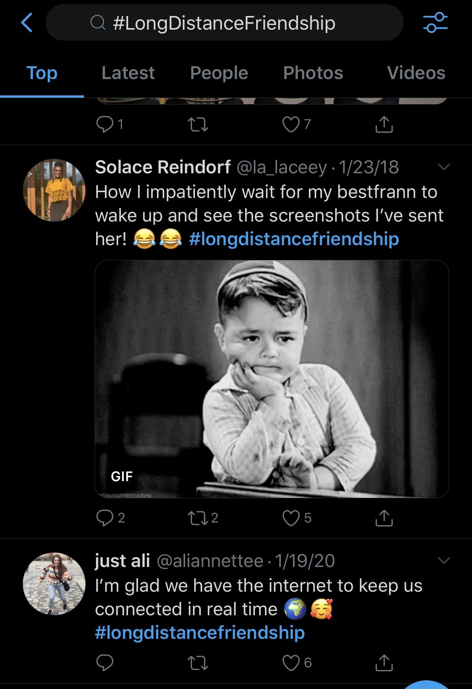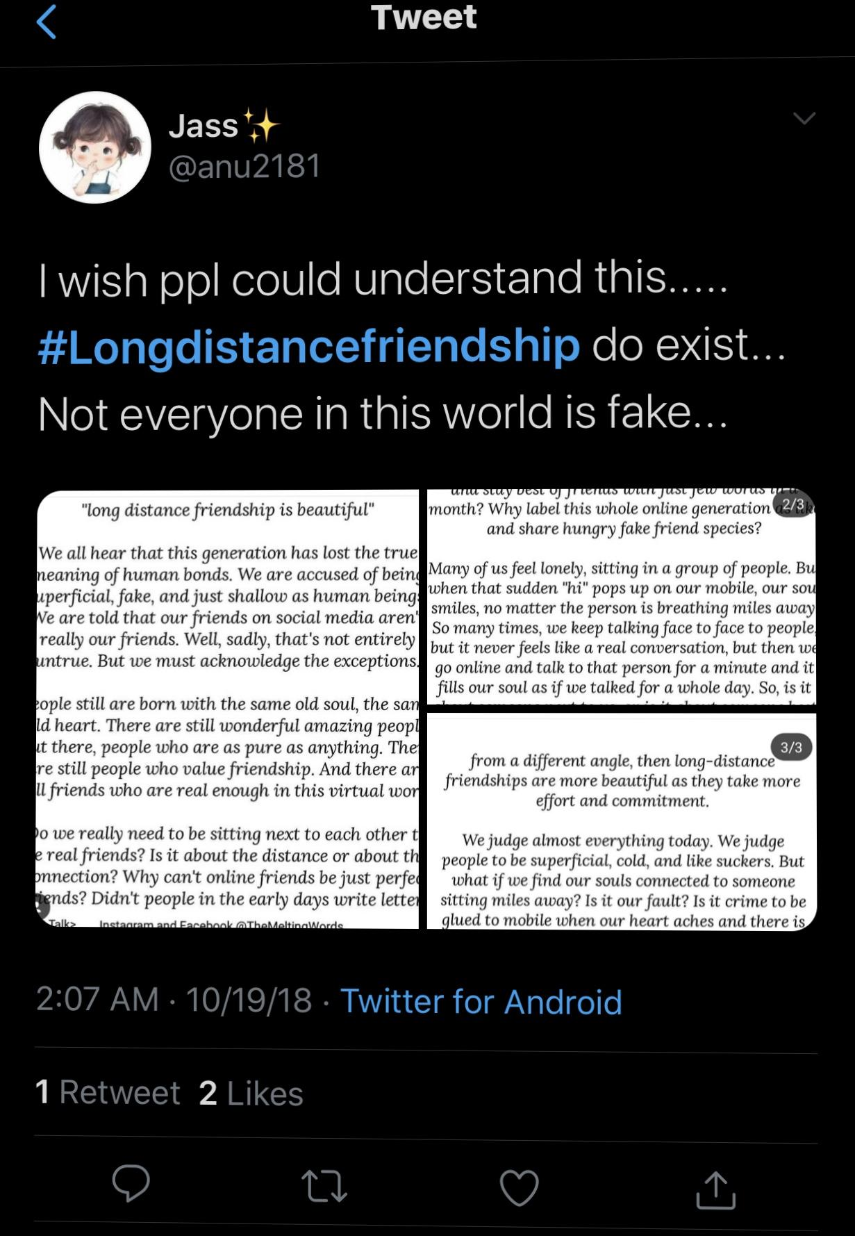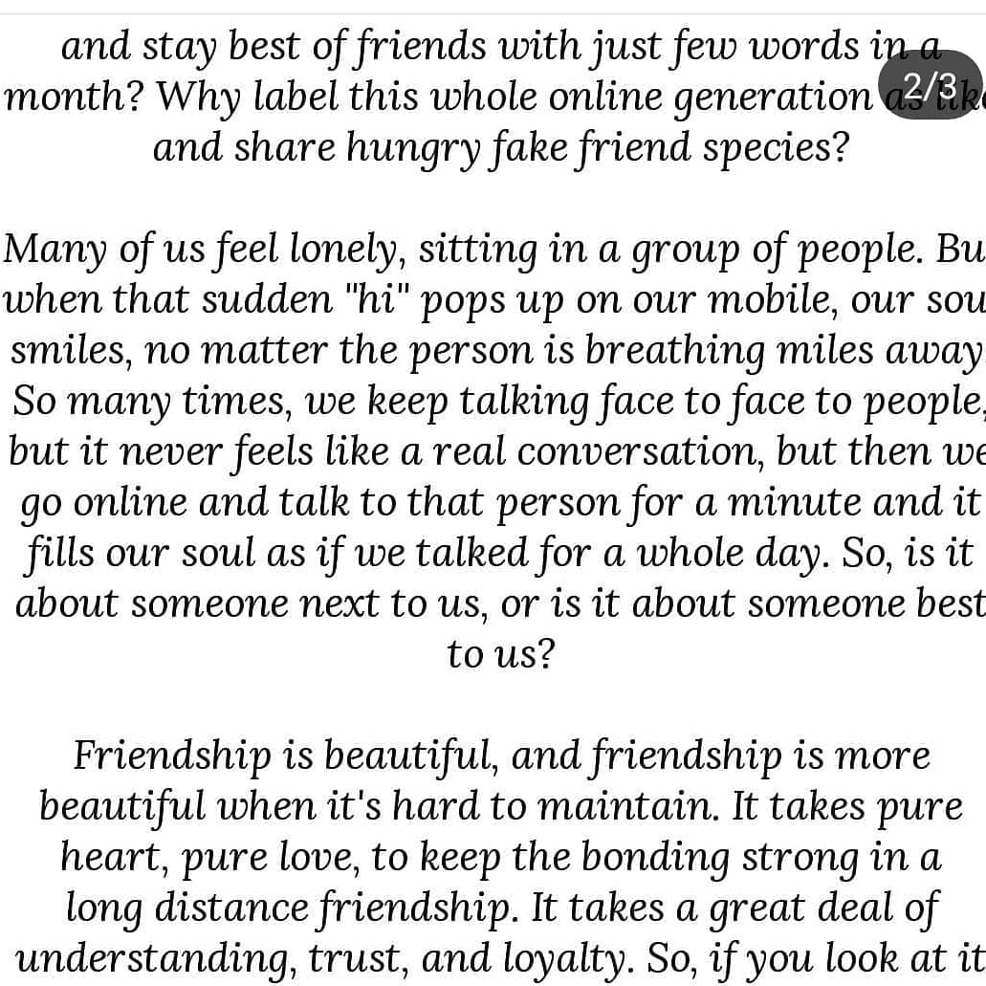

These posts and blogs seemed to help a bit such as gaining more knowledge of the topic, but I don’t think I can use some of these things in my final paper.

Resources:
Briche, Chelsea. “How To Maintain A Long Distance Friendship.” Www.themillennialmiss.com, www.themillennialmiss.com/blog/how-to-maintain-a-long-distance-friendship.

https://mashable.com/article/long-distance-best-friends/

